|  |
| --- |
|  |
| Project 1 |
|  |
|  |

Table of Contents

introduction 3

body of report 4

section 1 (task 1) 5-6

section 2 (task 2) 7-11

section 3 (task 3) 12-14

section 5 (task 5)……………………………………………………………………………………………………………………………………………………15-19

conclusion 20

APPENDIX 21-27

|  |  |
| --- | --- |
|  | Decorative |
| introduction |
| I am a Network Administrator working at RMIT University. My daily tasks include the following:   * Setting up networks * Managing networks * Configuring network security * Configuring network services * Troubleshooting network problems   It is projected that there will be a large increase in student intakes at RMIT University in the next 3 to 5 years. To meet this demand RMIT University has allocated a budget for purchasing additional computers for new labs being built. As the network administrator, I will be required to develop a pilot application that will accurately identify the number of networks needed to connect the additional computers to RMIT’s IT systems. |
|  |
|  |

|  |  |  |
| --- | --- | --- |
|  |  |  |
|  |  | body of report |
|  |

|  |  |
| --- | --- |
|  |  |
| **section 1 (task 1)** |
| ***The Software Development Life Cycle (SDLC) process that will be followed for creating this application:***   1. **Planning Stage**   *In the planning stage the following must be covered:*   * Define the software to develop * Define the scope and also the purpose of the software * Define the goals of the software * Define resources to develop the software * Define target audience for the software * Define the timeframe to develop the software * Define the budget to be able to develop the software * Define the project team to develop the software  1. **Requirements Stage**   *Within the requirements stage the following is to be covered:*   * Define the features of the software * Define the functionality of the software * Define the compatibility of the software with existing systems * Define the need of the target audience for the software – Methods such as surveys, social media, interviews, emails, website or observations can be used to gather information from target audience about the software.  1. **Design Stage**   *In the design stage a documentation is written to explain how to develop the software, this document is known as design documentation specifications (DDS), it must include:*   * User interface layout of the software * Colour schemes of the software * Framework used to develop the software * Programming languages used to develop software * Network infrastructure of the software * Security mechanisms of the software * Platforms that the software will run on * Algorithms for solving problems and performing tasks in the software  1. **Implementation Stage**   *This is where the software will start being developed using the chosen programming language specified in the DDS. If the DDS contains detailed information, software development can then be completed without any issues.*   1. **Testing Stage**   *This is where the software is thoroughly tested to ensure it functions as expected and also to resolve any errors identified, Variety of testing methods are performed on the software such as:*   * Compatibility Testing * Performance Testing * Usability Testing * Security Testing * Functional Testing  1. **Deployment Stage**   *The software is released in the market to be used by the target audience after the testing is complete done and all errors have been resolved.*   1. **Maintenance Stage**   *This is where the software is continuously monitored and modified after being released in the market to ensure that it keeps functioning as expected, also all updates and upgrades of the software occur during the maintenance stage.*  *Below are the 4 types of software maintenances:*  Preventative maintenance: The software is modified to remove any minor vulnerabilities uncovered before they become major errors in the future.  Corrective maintenance: The software is being modified to remove any major errors that are currently uncovered by the target audience.  Adaptive maintenance: This is where the software is modified to make it compatible with newer hardware components.  Perfective maintenance: The software is then modified to enhance performance and also to improve usability. |

|  |
| --- |
|  |
| **section 2 (task 2)** |
| **What is the scope of the project?**  Objective:   * The new additional computers that is capable of distributing a large increase in student intakes at RMIT University. Also, will be required to develop a pilot application that will identify the number of networks needed to connect the additional computers to the RMIT’s IT systems.     Purpose:   * The current computers are outdated and is not capable of distributing a large number of student intakes within RMIT University.   Functions:   * Selection constructs with operators to validate the inputs entered by the user * Iteration construct for continuously running the program until the exit option is entered by the user * Correct syntax for the code as specified in the technical documentation of the scripting language * 3 comments included in the code to explain what is happening * Code is executed in a sequential order from top to bottom * Variable for storing the menu option selected by the user * Variable for storing the number of subnets entered by the user * Use debugging techniques to detect and correct errors with the code for variables, selection and iteration if any of the specified tests did not work as expected.   Resources:   * Bash programming language (Version) * Gedit or nano text file * Visual Studio Code (IDE Application) * Web browser (Chrome/Edge/Firefox/Safari) * Operating System (Android/iOS/Linux OS/MacOS/Windows OS)   Deliverables:   * Algorithms * Software Application * User Manual * Technical Documentation   Constraints:   * Issues within the coding * Budget issues * Poor risk management * Software developers are involved in multiple projects * Some of the software developers are recruits * Number of software developers involved with the software application * Newer versions of the web browser(s) * Newer versions of the operating system(s) * Errors discovered with the software application * Budget allocated for the software application     Target Audience:   * RMIT students * Administrative Staff * Software Developers   Budget:   * $50,000 - Small   Deadline:   * 30th of September   **Identify 2 design specifications that you need to adhere to?**   * The script must display the correct output for numbers of subnets. * Script must display error messages for when the user enters invalid number of subnets for example if they enter a minus number, greater than 64 number, an alphabetic letter or even a special character an error message will get displayed on the screen. * Script must also have error message displayed for entering an invalid menu option such as 0, a minus number or a number higher than 2 as the menu has only 2 options which are to Display subnetting details and Exit.   **What scripting language would you use to write the code?**  The scripting language I would use to write this code would be Linux Bash.  **What are 2 characteristics of this language that you need to consider in your design?**  The 2 characteristics of using bash that need to be considered are:   * It runs multiple programs in the background. * Perform arithmetic calculations such as addition, subtraction, division, and multiplication.   **You must clarify with the teacher which IP Addressing Scheme will be included in your pilot software.**  **IP Addressing Scheme:**  **Entering 1 subnet**  **Entering 2 subnets**  **Entering 3 or 4 Subnets**  **Entering specific number from 5 to 8 for subnet range**  **Entering specific number from 9 to 16 for subnet range**  **Entering specific number from 17 to 32 for subnet range**  **Entering specific number from 33 to 64 for subnet range** |
|  |
|  |
|  |
|  |

## **section 3 (task 3)**

**Algorithm Plan for application that will identify the number of networks needed to connect the additional computers to the RMIT’s IT systems:**

Step 1 – Open up the application

Step 2 –The menu will be displayed in order to be able to identify the number of subnet networks needed to connect to additional computers to RMIT’s IT system. (output)

Step 3 – User will be required to enter either options 1 or 2. (input)

*If user enters number 1, they will then be prompt to enter the number of subnets they want displayed on the screen. (input)*

*If user enters number 2 the application will then exit. (input)*

* *If a user enters a number less than 1 or more than 2 an error message will be displayed. (output)*
* *If enter a special character, uppercase or lowercase letter the error message will still get displayed. (output)*

Step 4 – Display Subnetting Details:

*After the user enters option 1 at the menu, they will be prompt to enter number of subnets. (input)*

* The user has the option to select only the number 1 for number of subnets (input)
* Once entered the following details will appear on the screen: (output)

Bits Borrowed: 0

Subnets needed: 1

Address per subnet: 256

Hosts per subnet: 254

Subnet Mask: 255.255.255.0

Prefix: /24

* The user has the option to select only the number 2 for number of subnets (input)
* Once entered the following details will appear on the screen: (output)

Bits Borrowed: 1

Subnets needed: 2

Address per subnet: 128

Hosts per subnet: 126

Subnet Mask: 255.255.255.128

Prefix: /25

* The user has the option to select the numbers 3 or 4 for number of subnets (input)
* Once entered the following details will appear on the screen: (output)

Bits Borrowed: 2

Subnets needed: 4

Address per subnet: 64

Hosts per subnet: 62

Subnet Mask: 255.255.255.192

Prefix: /26

* The user has the option to select the numbers from 9-16 for number of subnets (input)
* Once entered the following details will appear on the screen: (output)

Bits Borrowed: 3

Subnets needed: 8

Address per subnet: 32

Hosts per subnet: 30

Subnet Mask: 255.255.255.224

Prefix: /27

* The user has the option to select the numbers from 17-32 for number of subnets (input)
* Once entered the following details will appear on the screen: (output)

Bits Borrowed: 4

Subnets needed: 16

Address per subnet: 16

Hosts per subnet: 14

Subnet Mask: 255.255.255.240

Prefix: /28

* The user has the option to select the numbers from 33- 64 for number of subnets (input)
* Once entered the following details will appear on the screen: (output)

Bits Borrowed: 6

Subnets needed: 64

Address per subnet: 4

Hosts per subnet: 2

Subnet Mask: 255.255.255.252

Prefix: /30

Step 5 – The user will be able to exit the application (input)

*If the user enters the number 2 at the menu the application will exit (output)*

* *Please Note if a user enters less than 1 or more than 2 an error message will be displayed (output)*
* *Please Note If user enters a letter or special character an error message will also be displayed (output)*

## 

## **section 5 (task 5)**

## 

## **Task 5A & 5B: TABLE below to create 2 tests/Completed table filled in accordingly.**

|  |  |  |
| --- | --- | --- |
| **How the tests are being conducted (5-15 words per test)** | **Test Outcome Success (10-15 words per test)** | **Modifications Required (10-15 words per test)** |
| **Test 1 (allow authorised):**   * Try entering a 2 on the menu for the option, does the application allow it? * When entering 64 for the number of subnets, does it display the subnet details and allow it? * Try entering a 1 on the menu option, what does it do and does the application allow it? | Yes, when I enter 2 for the option at the menu, the application allows it and it exits the application.  Yes, when I entered 64 in the number of subnets it displayed the correct details for subnet 64 and it was allowed.  Yes, when I tried to enter number 1 at the menu option it then mentioned to enter the number of subnets and the application allowed it. | No modifications required |
| **Test 2 (blocking authorised):**   * Try using an invalid number or special character on the following:   Main menu where prompts you to enter option, does the application block it?  Where it prompts you to enter number of subnets, did the application block it?   * Try using a capital K and lowercase k where it prompts you to enter something for menu options, does the application block it? |  |  |

**Task 5C:**

**Shows that specified tests are now working as expected (shown in screenshots)**

Test 1 - Shows that when entering umber 2 on the menu for the options, it then exits the application and application allows it.

Test 1 - Shows that when entering 64 for the number of subnets to see if it displays correct details, it displays all information correctly and application allows it.

Test 1 - Shows when enter number 1 on menu option it asks you to enter number of subnets, application allows it.

Test 2 - Shows entering an invalid number on the menu where says to enter option, application blocks it.

Test 2 - Shows when entering special character for number of subnets, application blocks it.

Test 2 - Shows when enter uppercase and lowercase K at menu options, the application blocked it.

**Task 5C: Shows that all the steps addressed in the algorithm plan are now covered.**

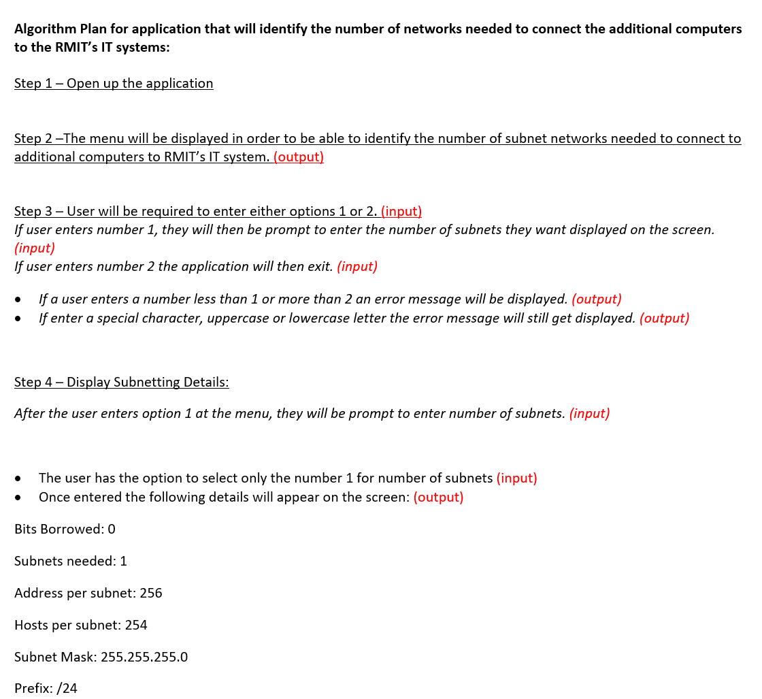

All the screenshots of the steps listed above have all been checked and all work.

## conclusion

I am a network administrator working at RMIT University, due to their being a large increase in student intakes at RMIT University in the next 3 to 5 years we’ve successfully allocated a small budget of $50,000 to purchase additional computers for new labs that have been built recently. All RMIT students, administrative staff and software developers such as myself can use these facilities. In relation to being able to develop this new pilot application that will accurately identify the number of networks needed to connect the additional computers to RMIT’s IT system.

Throughout developing this new pilot application to allow the number of networks needed to be identified and able to connect to additional computers at RMIT’s IT system I have been able to create the software application, user manual/requirements, algorithms, technical documentation, client report and ensure I have done all the appropriate testing and evaluation of the new software application as required for being the network administrator and I have managed to successfully fulfill all my duties as per working with RMIT University.

Thankyou,

## 

## APPENDIX

**Appendix 9.1: Bash Program File Subnetting.sh**



**Appendix 9.2: Section 2 Task 2 – IP Addressing Scheme**

**IP Addressing Scheme:**

**Entering 1 subnet**

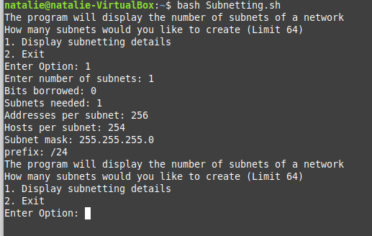

**Entering 2 subnets**

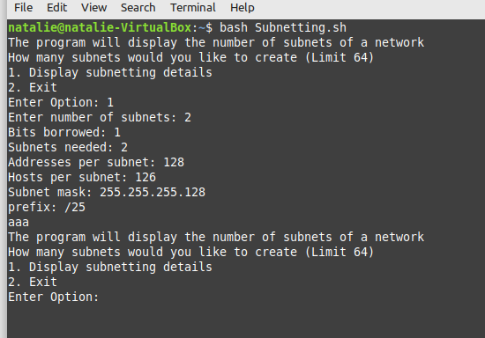

**Entering 3 or 4 Subnets**

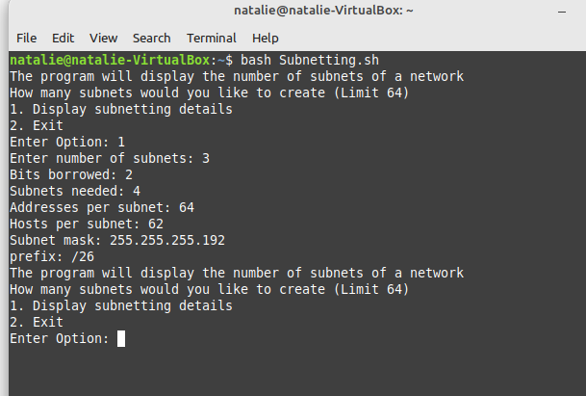

**Entering specific number from 5 to 8 for subnet range**

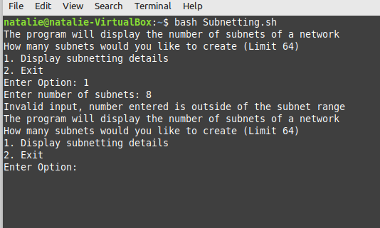

**Entering specific number from 9 to 16 for subnet range**

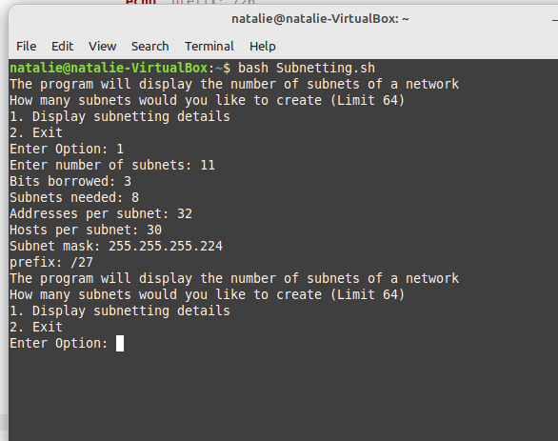

**Entering specific number from 17 to 32 for subnet range**

**Appendix 9.3: Task 5A/5B: Table for testing purposes**

|  |  |  |
| --- | --- | --- |
| **How the tests are being conducted (5-15 words per test)** | **Test Outcome Success (10-15 words per test)** | **Modifications Required (10-15 words per test)** |
| **Test 1 (allow authorised):**   * Try entering a 2 on the menu for the option, does the application allow it? * When entering 64 for the number of subnets, does it display the subnet details and allow it? * Try entering a 1 on the menu option, what does it do and does the application allow it? | Yes, when I enter 2 for the option at the menu, the application allows it and it exits the application.  Yes, when I entered 64 in the number of subnets it displayed the correct details for subnet 64 and it was allowed.  Yes, when I tried to enter number 1 at the menu option it then mentioned to enter the number of subnets and the application allowed it. | No modifications required |
| **Test 2 (blocking authorised):**   * Try using an invalid number or special character on the following:   Main menu where prompts you to enter option, does the application block it?  Where it prompts you to enter number of subnets, did the application block it?   * Try using a capital K and lowercase k where it prompts you to enter something for menu options, does the application block it? | Yes, while using an invalid number on the main menu for the options the application blocks it from doing so.  Yes, when I entered a special character for the number of subnets the application blocks it.  Yes, when I entered the uppercase and lowercase k, the application also blocked it. | No modifications required |

**Appendix 9.4: Task 5C – Screenshots showing specific tests are working as expected.**

Test 1 - Shows that when entering number 2 on the menu for the options, it then exits the application and application allows it.

Test 1 - Shows that when entering 64 for the number of subnets to see if it displays correct details, it displays all information correctly and application allows it.

Test 1 - Shows when enter number 1 on menu option it asks you to enter number of subnets, application allows it.

Test 2 - Shows entering an invalid number on the menu where says to enter option, application blocks it.

Test 2 - Shows when entering special character for number of subnets, application blocks it.

Test 2 - Shows when enter uppercase and lowercase K at menu options, the application blocked it.

**Appendix 9.5: Task 5C: Shows that all the steps addressed in the algorithm plan are now covered.**



All the screenshots of the steps listed above have all been checked and all work.